EB362R
Installation Instructions for IO Expansion Card

- Product Confirmation

EB362R board | M3 Screw
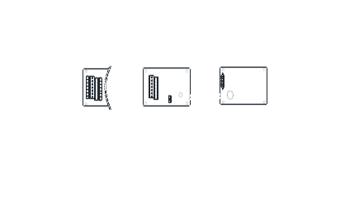 | 

- Component Name
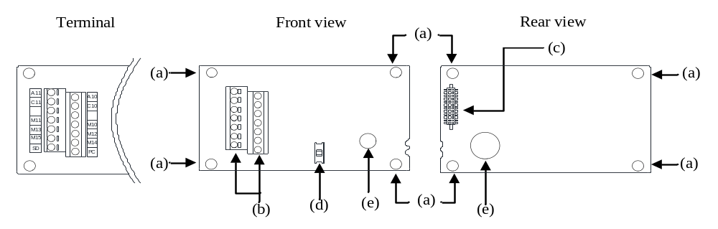
No. | Name | Instructions
a | Mounting hole | Use M3 screw to install the EB362R board to the inverter
b | Terminal | Connect wiring for customer
c | Connector | Connect to the inverter
d | Switch | Switch to SINK or SOURCE, and the default state is SINK.
e | Plastic handle | Remove EB362 board

- Electrical Specifications

Terminal form | Terminal name | Function instructions | Terminal specification
Switch signal input | M10 | There are totally 6 multifunction expanded control terminals. (Sink/Source can be switched) | Input impedance: 4.7 kΩ  Action current: 5mA  Voltage range: 10~28VDC  Maximum frequency: 1kHz
Switch signal input | M11
Switch signal input | M12
Switch signal input | M13
Switch signal input | M14
Switch signal input | M15
Relay output | A10，C10 | Multi-function relay outputs 2 groups;  A-C is the normally open contact | Maximum voltage: 30VDC or 250VAC  Maximum current: Resistive load: 5A NO  Inductive load: 2A NO  (cosΦ=0.4)
Relay output | A11，C11
Public terminal | SD | The common terminal of Terminal M10~M15 (SINK) | ---
Public terminal | PC | The common terminal of Terminal M10~M15 (SOURCE) | Output voltage: 24VDC±20%  Maximum current: 200mA(share with control board)

- Wiring Schematic Diagram
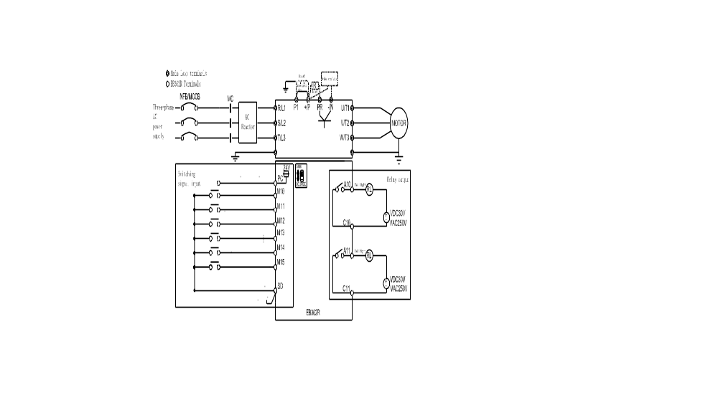
- Installation(SA3)
Step1: As the Figure 1 shows, please insert EB362R into the control board SLOT 2 or SLOT 3, not SLOT 1.
Step2: Please lock the two M3 screws with screwdriver according to the torque of 4-6kgf.cm and the direction showed in
Figure 2.
Note: When removing EB362R board, please first remove the right and left M3 screws, and then lift the plastic handle by hand.
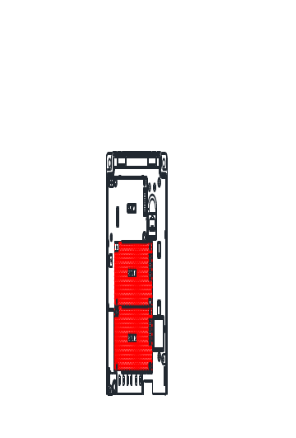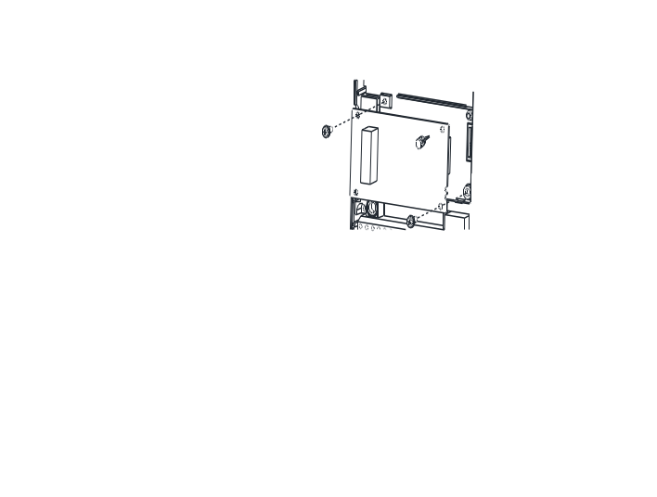
Figure 1 Figure 2

- Installation (SE3)
Step 1：Turn off the power.
Step 2：Open the top coverof the inverter.
Step 3：Use the front rear as support and slide (a) in by pressing down as figure 1 shown.

Figure 1
Note: (a)-Optional Card Housing; (b)-Hook, (c)-Slot
Step 4: Line up the connector (c) and (d), and press down the EB362R expansion card to the right position.
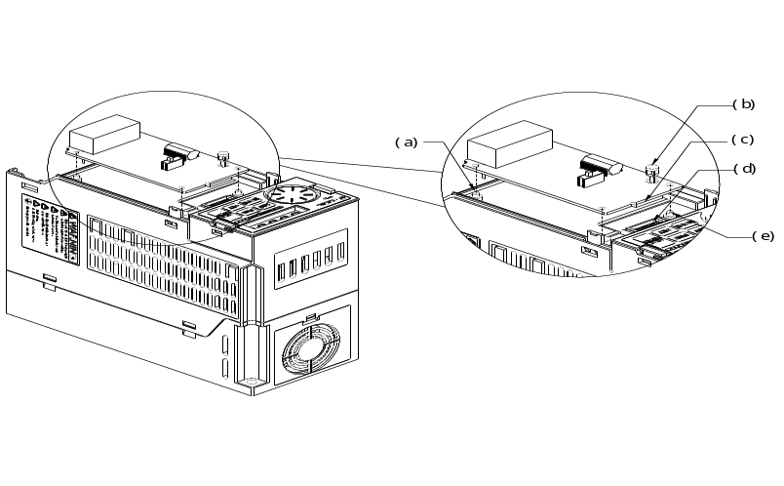
Figure 2
（a）(e)-Supporter, (b)-Plastic Handle, (c)-Male connector, (d)-Female connector
Step 5: Tighten two M3 screws with 4-6kgf.cm torque on the card. Install the cover after wiring.
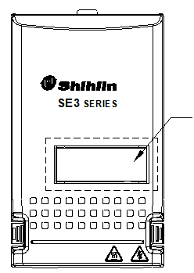
Need Cutout this area for installating the cover
Figure 3 Figure 4

- Others
To improve our products, the parameters and contents may be modified, please contact the agent or refer to Shihlin websites
(http://automation.seec.com.tw/) to download the latest version.



